GENERATIVE AI LAB – WEEK 3
Experiment: LLM Monitoring with MongoDB Connectivity
Name: G.ROHITH Roll No.: 2520030220
Date: 12/11/2026 Tool used: Visual Studio Code

Aim
To monitor LLM requests using MongoDB by recording the provider, model, prompt, token usage, latency, cost, attempts, and execution status.

Software used
VS Code, Python, Ollama, llama3.2, MongoDB Compass, MongoDB, PyMongo, google-genai, requests, python-dotenv, and pytest.

Procedure
1. Installed MongoDB Compass and configured a MongoDB connection using the local server or MongoDB Atlas.
2. Opened MongoDB Compass and created the llm_monitoring database with a call_logs collection.
3. Checked the Ollama model using ollama run llama3.2 and confirmed that it generated a response.
4. Created the WEEK-3/code project in VS Code with main.py, llm_client.py, mongo_logger.py, cost_calculator.py, requirements.txt, and environment configuration files.
5. In llm_client.py, used GeminiProvider and OllamaProvider with a common LLMClient to generate responses and collect token usage and elapsed time.
6. In cost_calculator.py, added example token-based cost calculations; local Ollama calls have no per-token API fee.
7. In mongo_logger.py, connected to MongoDB and saved each LLM call in llm_monitoring.call_logs with a timestamp.
8. In main.py, loaded the environment variables, selected Ollama, entered a prompt, displayed the response, and saved the call details.
9. Installed the required Python packages, ran main.py, and verified the saved records in MongoDB Compass.

Commands used
ollama run llama3.2
cd /Users/g.rohith/Desktop/GEN_AI/WEEK-3/code
python3 -m pip install -r requirements.txt
python3 main.py
Open MongoDB Compass → llm_monitoring → call_logs
The project uses google-genai, requests, python-dotenv, pymongo, and pytest. The screenshots show a successful local Ollama run and MongoDB records. The Gemini API path was not verified in the supplied screenshots.

Program flow
Start main.py → choose Gemini or Ollama → enter a prompt → LLMClient generates a response and records metrics → MongoLogger saves the call to MongoDB → response is printed.

Sample interaction (observed)
Select provider (1/2): 2
Enter your question: what is generative ai

AI RESPONSE:
Generative AI is a type of artificial intelligence that can generate new content, including text, images, music, and videos.
Screenshot: VS Code Week 3 project and environment configuration
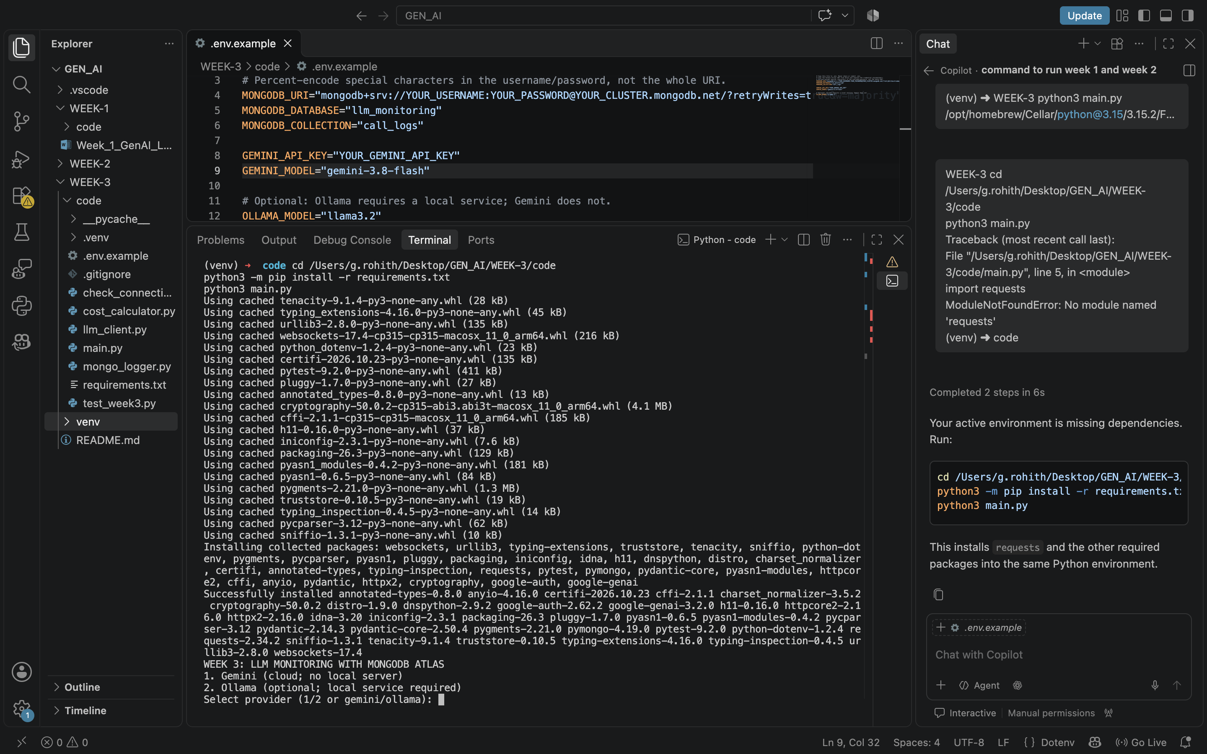

Screenshot: Ollama response and MongoDB logging in terminal

Screenshot: MongoDB Compass call_logs records
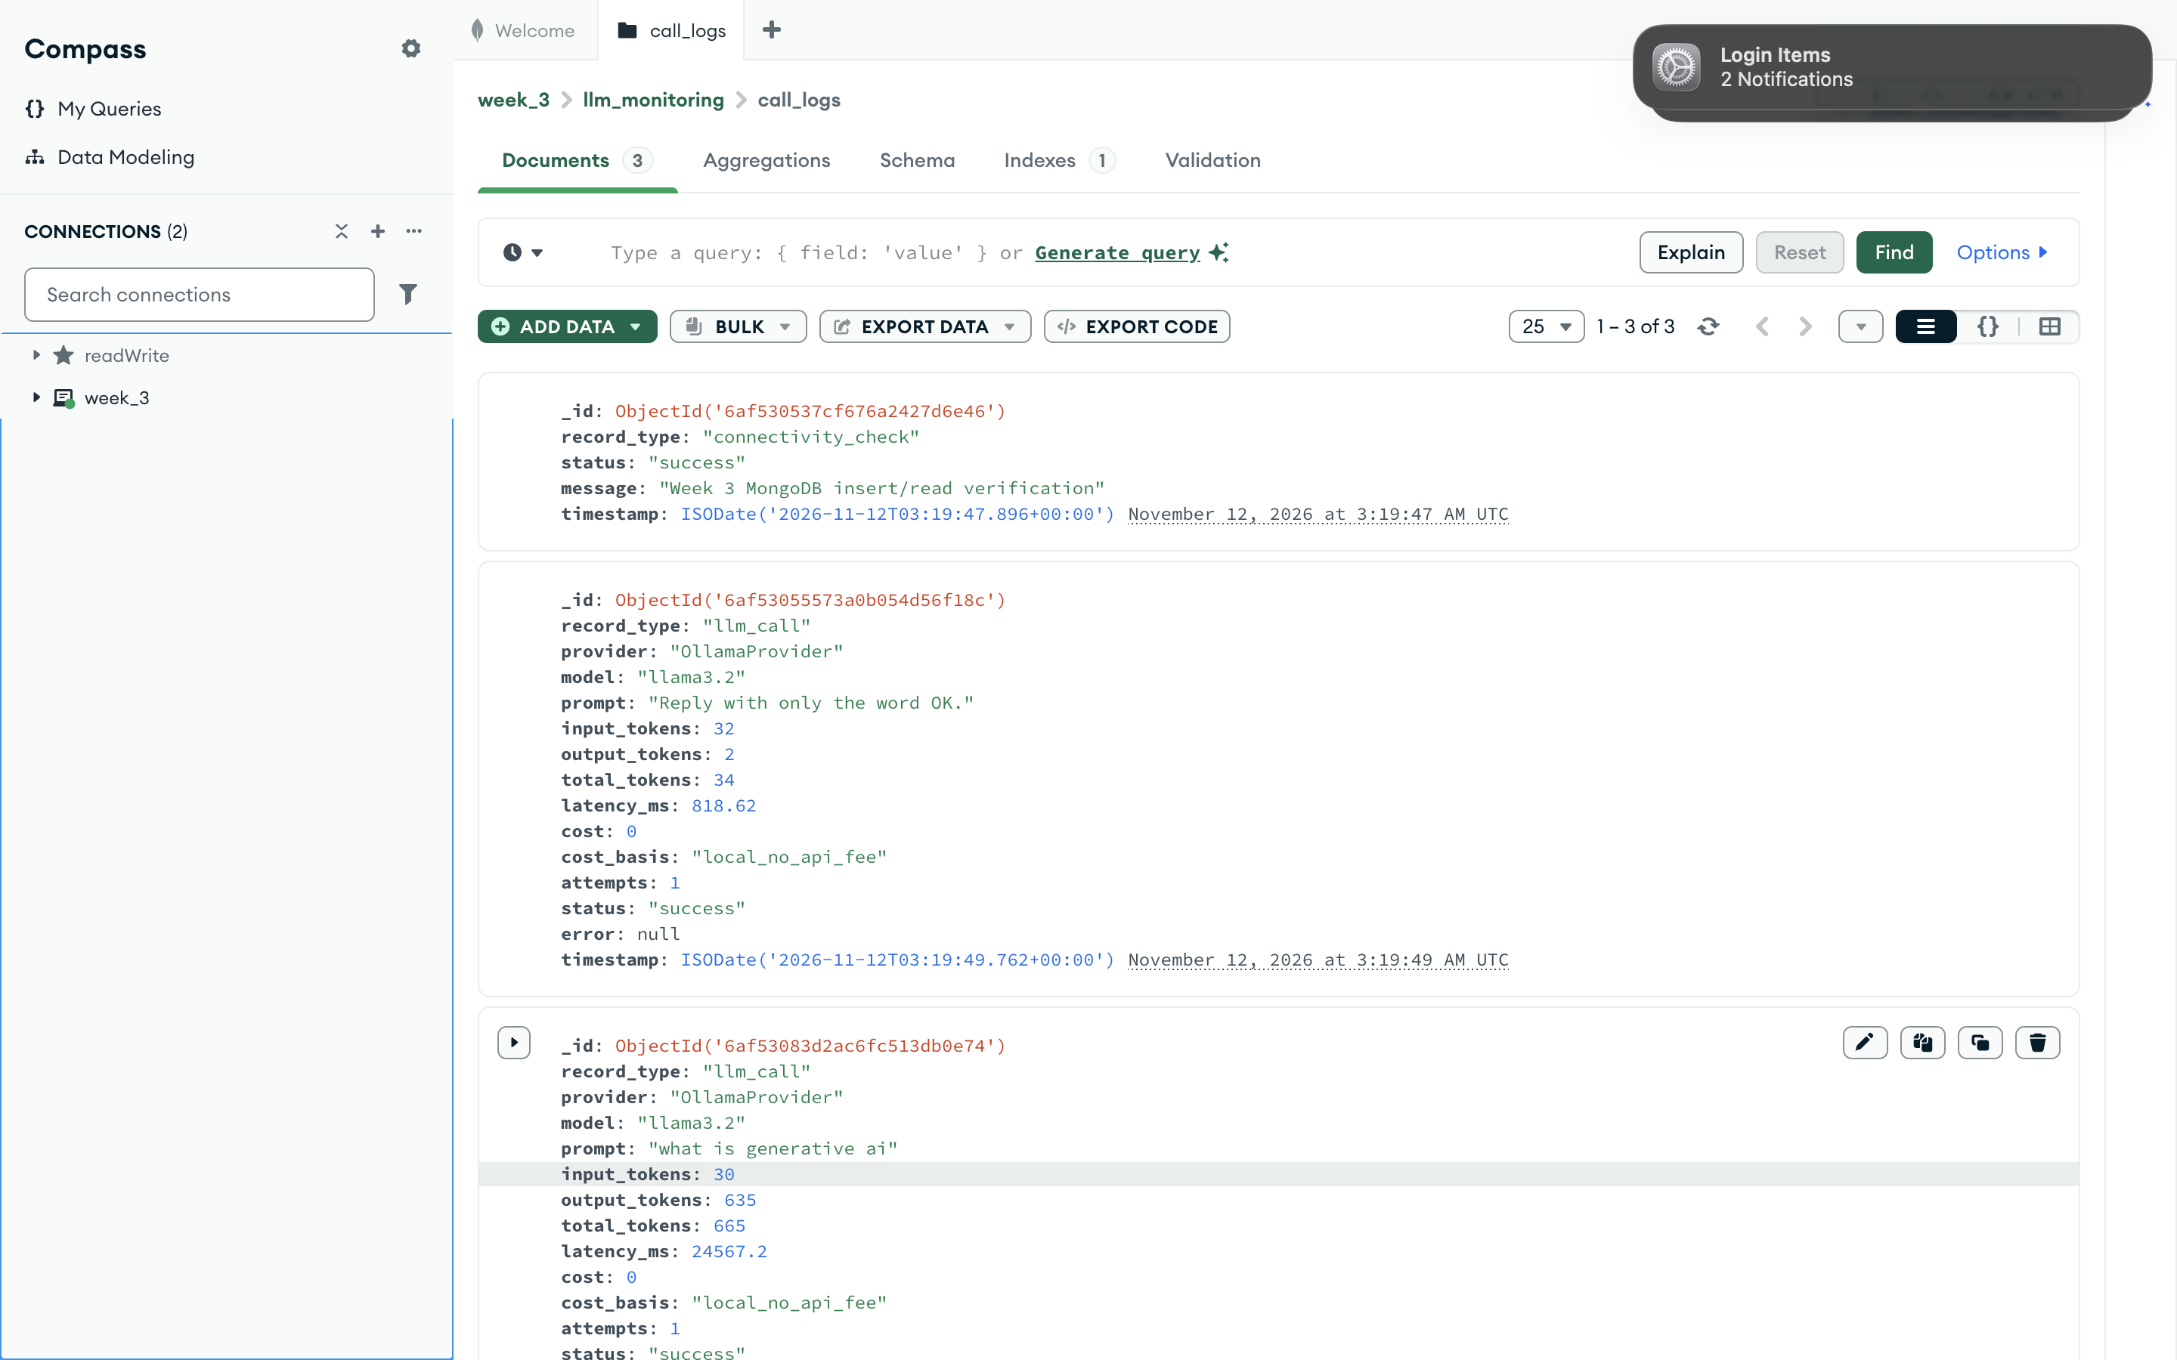

Output
Observed output: the program displayed an AI response, reported “MongoDB connection successful!”, and saved call details. MongoDB Compass showed successful OllamaProvider entries with model llama3.2, token counts, latency, cost 0, and timestamps.

Result
The Week 3 experiment successfully demonstrated LLM monitoring with the local Ollama provider. The response was generated and call metrics were stored in the llm_monitoring.call_logs collection.
Result recorded by me: Successful Ollama execution and MongoDB log verification.

What I learned
I learned how to connect Python to MongoDB, record LLM prompts and usage metrics, calculate estimated costs, and verify stored call logs using MongoDB Compass.

